Cotrassenyes i usuaris:
Ordinador lab: labtelemN, telematicaN
Simctl ova: telem, telem
Dins simctl: root, xxxx
Subshell:
Simctl iptunnel sh
Per sortir: exit
Commands:

0.4. Configuring IPIP tunnels
R2: ip tunnel add tunnel0 mode ipip local 198.51.100.2 remote 192.0.2.2 ttl 0 nopmtudisc dev eth2
R2: ifconfig tunnel0 1.2.3.4
R2: route add -net 192.168.0.0/24 dev tunnel0
R1: ip tunnel add tunnel0 mode ipip local 192.0.2.2 remote 198.51.100.2 ttl 0 nopmtudisc dev eth2
R1: ifconfig tunnel0 1.2.3.4
R1: route add -net 172.16.1.0/24 dev tunnel0

0.5. Testint the tunnels: protocol and TTL fields
a)L’opció –c indica el número de paquets ping que s’envien.
b) Funciona el ping? Sí, el ping funciona correctamente
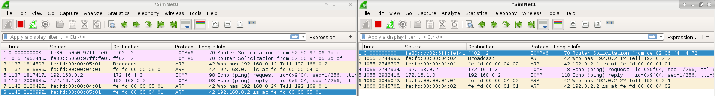
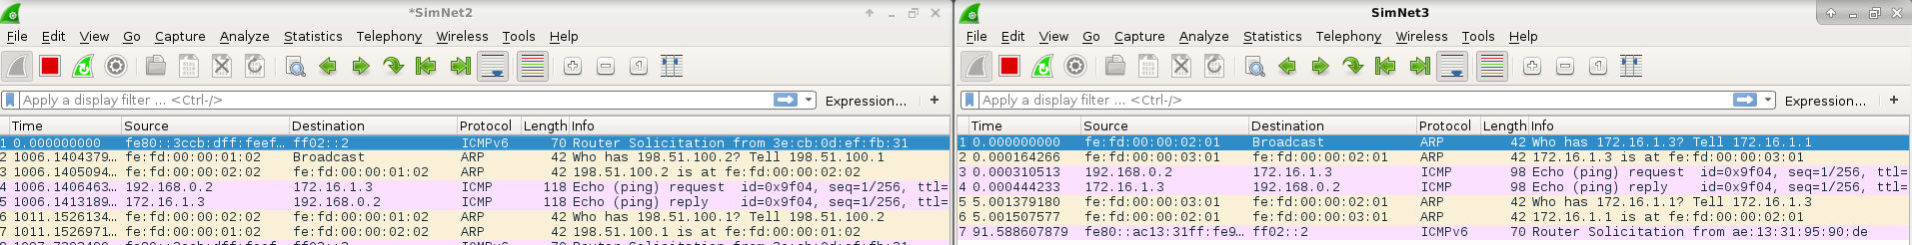
3)
a) El paquet IP que veiem a SN1 i SN2 està encapsulat utilitzant IPIP. Podem veure que té dues capçaleres IP amb un valor de Protocol field: IPIP (4). El valor del protocol field de la Outer Header és ICMP (1)
b) Podem observar una diferencia de dimensions entre el paquet de SN0 (length 98) amb el de SN1 (length 118) de 20Bytes.
c)
TTL | SimNet 0 | SimNet 1 | SimNet 2 | SimNet 3
Outer Header | X | 63 | 63
Inner Header | 64 | 63 | 62 | 62

4)
a)host2:ping –c1 –t1 172.16.1.3
Només veiem al SN0 ja que gasta l’unic ttl al primer router, per això no pot continuar, per tant no arriba al destí. Necessita un ttl=3 per arribar al destí. Veiem el paquet d’error Time-to-live exceeded entre el R1(192.168.0.1) i el R2(192.168.0.2).
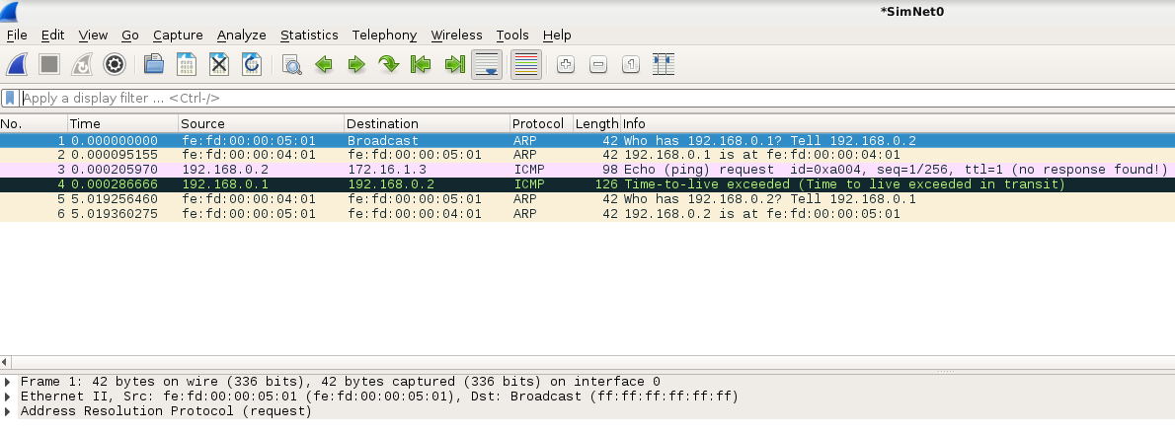
Now clear all the wiresharks and send again another ping, but with TTL=2.
host2: ping -c1 -t2 172.16.1.3
- Did the packet reach the destination host? In which machine the packet was lost?´
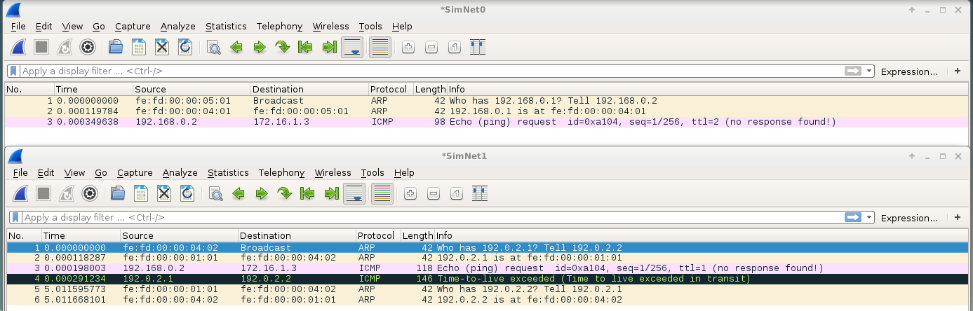
- Can you see any ICMP error message? Which one? In which network?
In SN1 we can se the Time to live extinct
- Which is the origin and destination IP addresses of this error message?
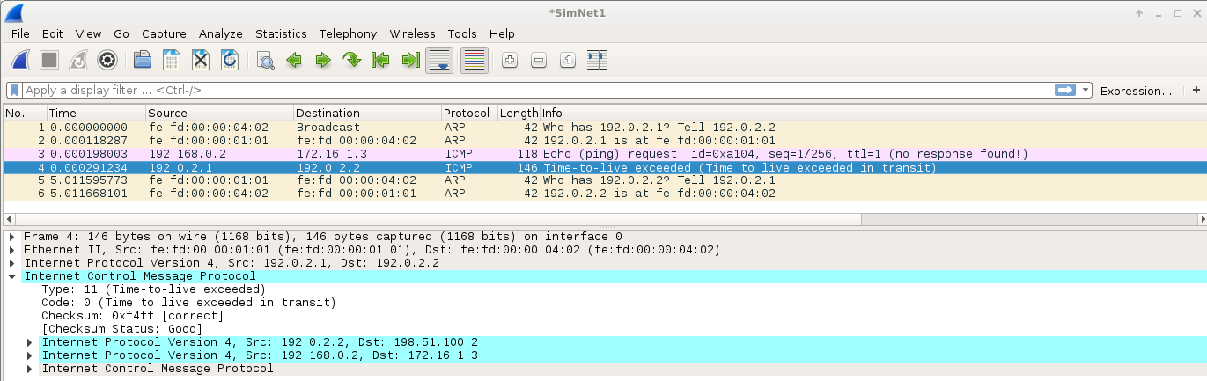
- Can you see any ICMP replaying?
No, because the user the ICMP request didn’t reach the final destination, so it is not possible to generate a reply
- Send again the same ping with TTL=2. Is there any soft state?
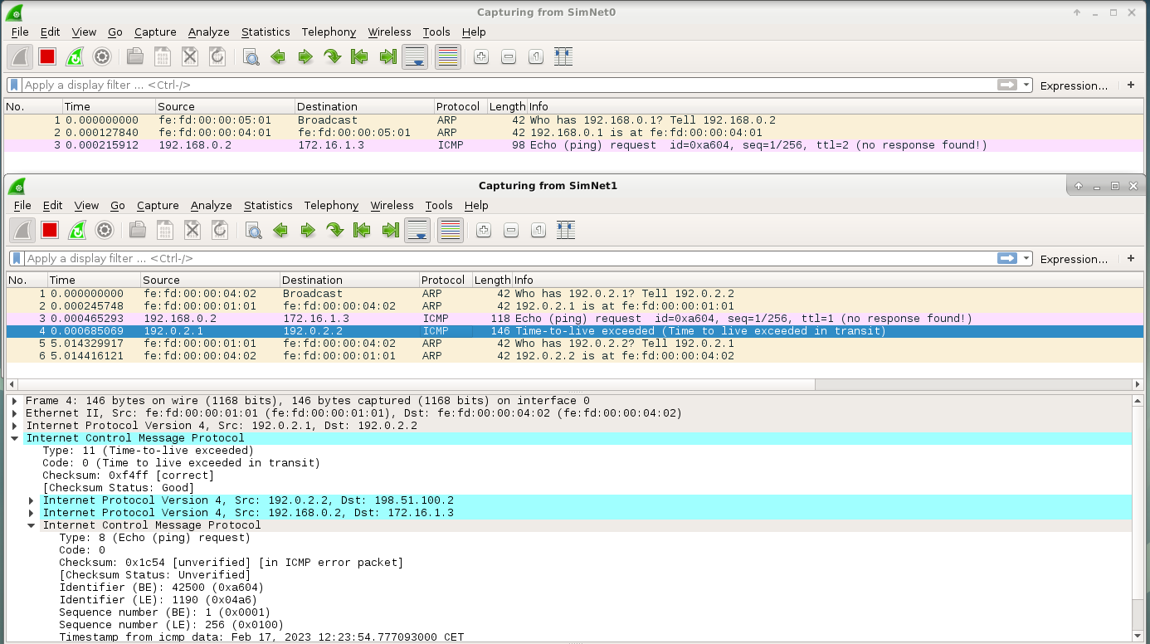
- Is this behavior compliant with RFC 2003 (see section 4.4)?

Now use TTL=3:
host2: ping -c1 -t3 172.16.1.3
- Did the packet reach the destination host?
Yes, now it reached the destination host:
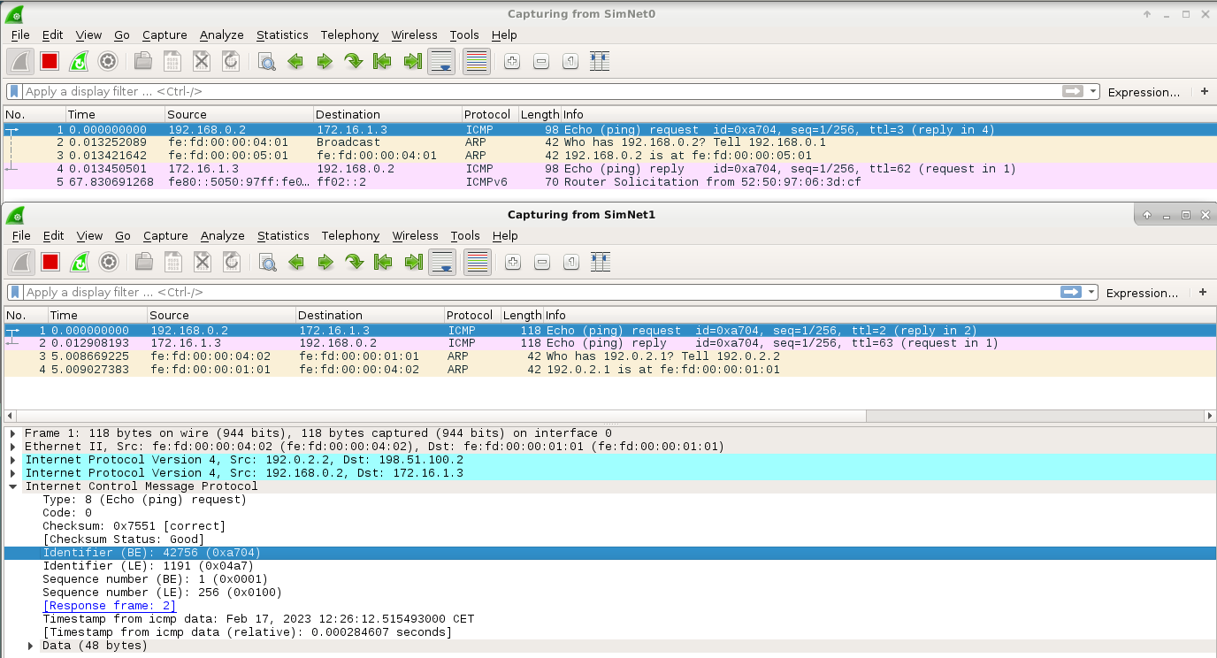
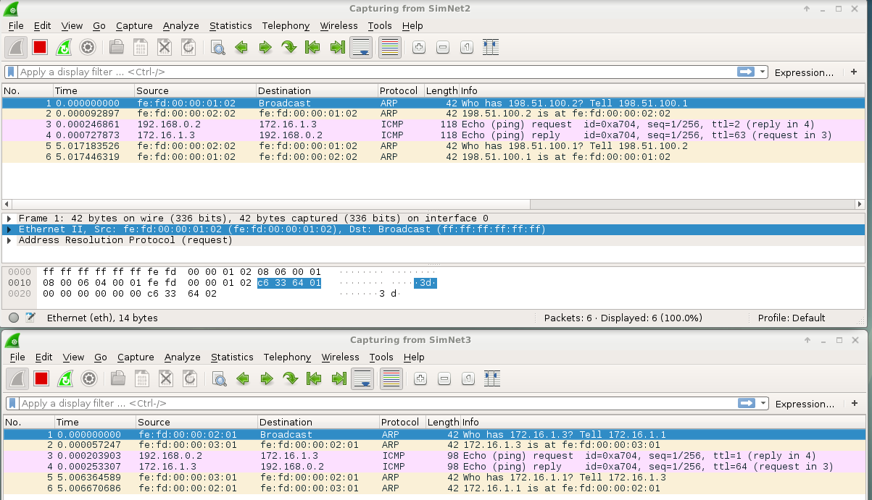
- Can you see any ICMP reply message?
Yes, now it can be seen the echo ping reply.

0.6.1 Limiting the MTU
1. Use ifconfig to see which is the value of the MTU in the tunnel interfaces both in R1 and R2:
R1/R2: ifconfig
a) which is the value?
We can observe the value of the MTU for the tunnel0 is 1480.
b) Is there any relationship between the MTU assigned to the tunnel and the MTU assigned to the physical interface?
The relationship is MTU_tunnel=1500(MTU ethernet) -20 (IPouter header)
2. Delete the previously configured tunnel in R2. Instead of doing it manually.
Host: simctl iptunnel exec deltun %Elimina el tunnel en els dos costas de R1 i R2
3. Change the MTU of SimNet2 to the value 996 bytes.:
R2: ifconfig eth2 mtu 996
RC: ifconfig eth2 mtu 996
4. Reestablish again the tunnel using the following script:
HOST: simctl iptunnel exec addtun_nopmtu
- Which is now the MTU in both sides of the tunnel?
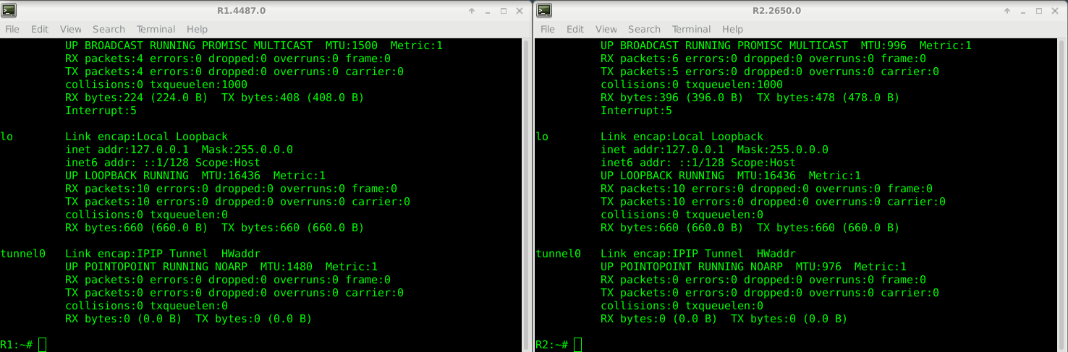
Al hacer el tunnel , el se adapta a la MTU de la interfaz física por donde va a salir. Pero cuando lo montamos los dos routers no comparten que MTU van establecer y por eso son diferentes.
- Why this change in the MTU value?
Como podemos ver la MTU es diferente. Entonces
Tunnel0 R1 → MTU = MTU (ETH2 interfaz fisica por donde sale) -20=1500-20= 1480B
Tunnel0 R2 → MTU = MTU (ETH2 interfaz fisica por donde sale) -20 = 996–20= 976B

0.6.2. Fragmentation fields and options
We pretend to see how the fragmentation fields of the Outer header depend on the Inner header and also on the configuration of the tunnel.
- Put all wiresharks listening traffic in all SimNet interfaces.
- Send the following ping from host2 to host3:
h o s t 2 $ ping 􀀀c1 􀀀s 500 􀀀M want 1 7 2 . 1 6 . 1 . 3
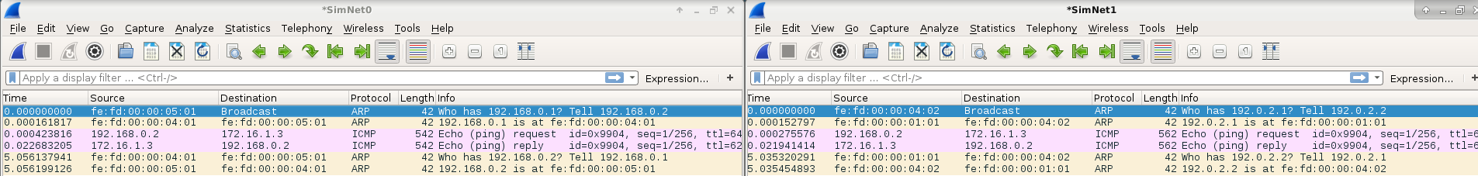
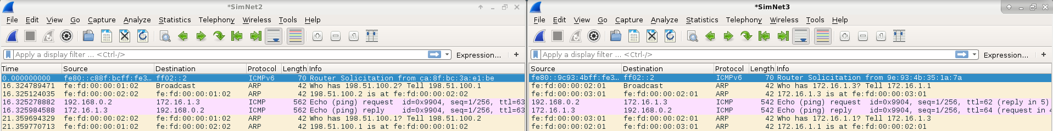
- How many ICMP packets can you see? What kind of packets?
One packet Echo (ping) request and one Echo (ping) reply for each simnet
- Which is the size of these packets? Describe the headers of these packets.
Echo ping request:
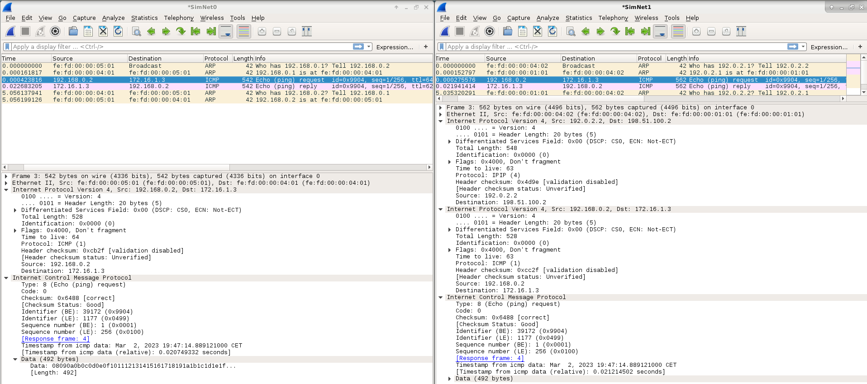
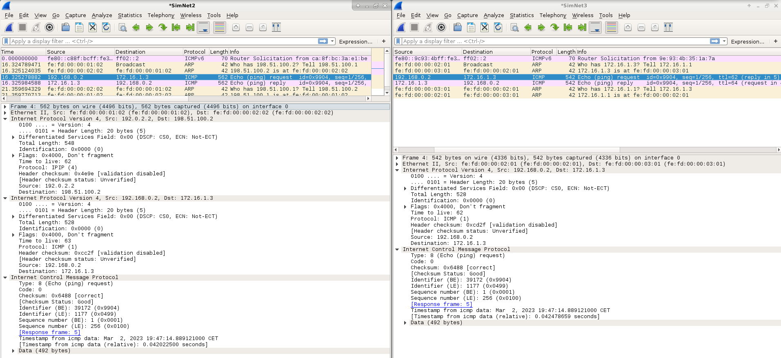
Echo ping reply:
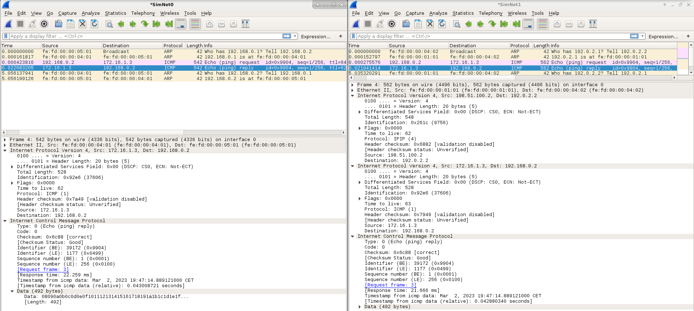
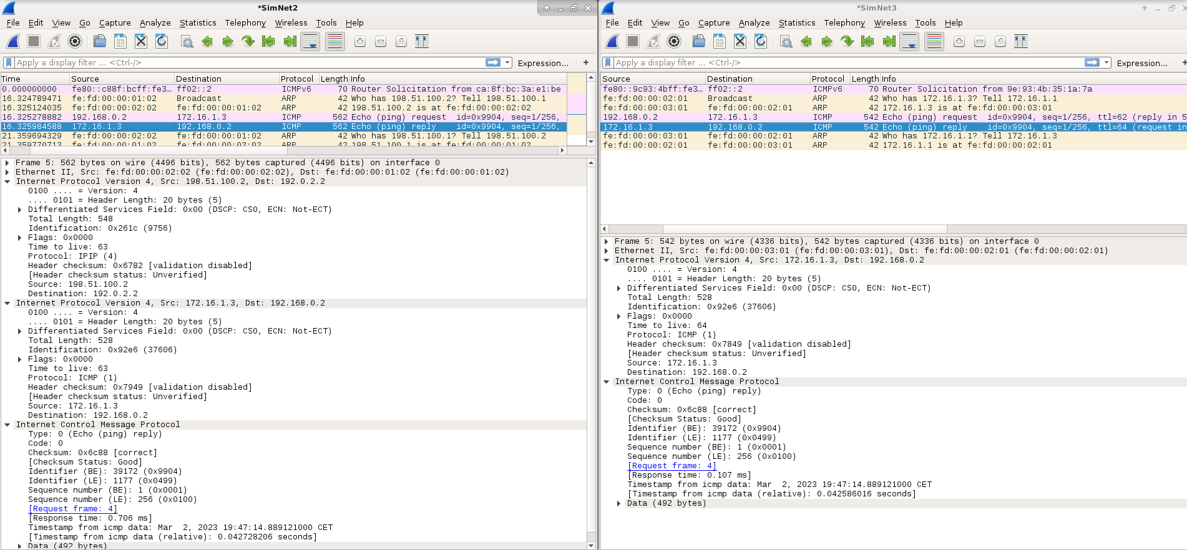
- Have these packets been fragmented? Why?
No, because it does not the maximum MTU of any net and it the tunnel does not allow to fragment packets
- Which is the value of the “don’t fragment” (DF) flag in the ICMP packets in SimNet0?
DF=1
- And in SimNet1, which is the value of DF in the Outer and Inner headers?
Yes, it has the same value, the tunnel is configured that the inner header gets copied to the outer header.
After this brief test, you should have noticed that the -s option is used to set the number of bytes in the “data” section of ICMP. The -M option is used to manage fragmentation in the origin host. The -M want option is intended to “do PMTU discovery, fragment locally when packet size is large”. That is, the DF flag is set by default, but when there is the necessity of fragmentation, the origin can do it.
- Now execute:
h o s t 2 $ ping 􀀀c1 􀀀s 500 􀀀M dont 1 7 2 . 1 6 . 1 . 3
- What is the difference compared to the previous test?
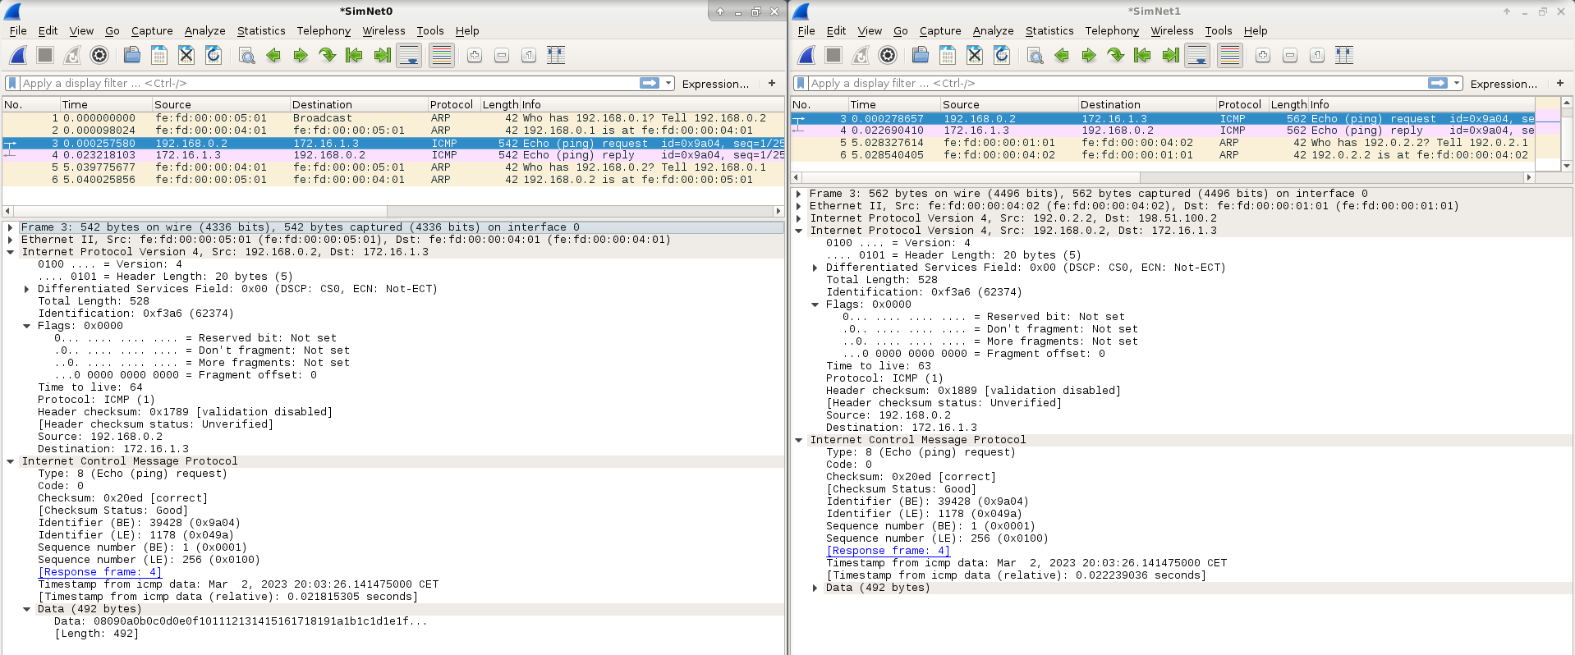
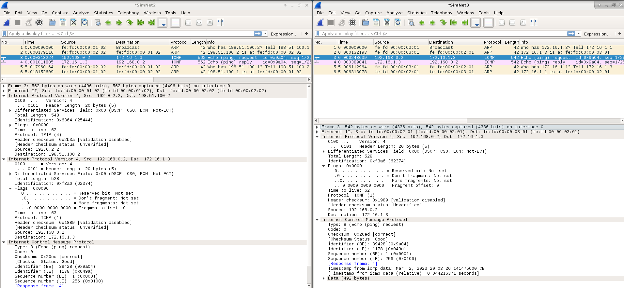
As you can see, the dont option (“do not set DF flag”) allows fragmentation in path.
- Now execute:
h o s t 2 $ ping 􀀀c1 􀀀s 500 􀀀M do 1 7 2 . 1 6 . 1 . 3
- Can you see any difference in wireshark compared to the first case? Is there any difference at all? The do option “prohibit fragmentation, even local one”. In this previous case you will see no difference, but later in other tests there can be some differences.
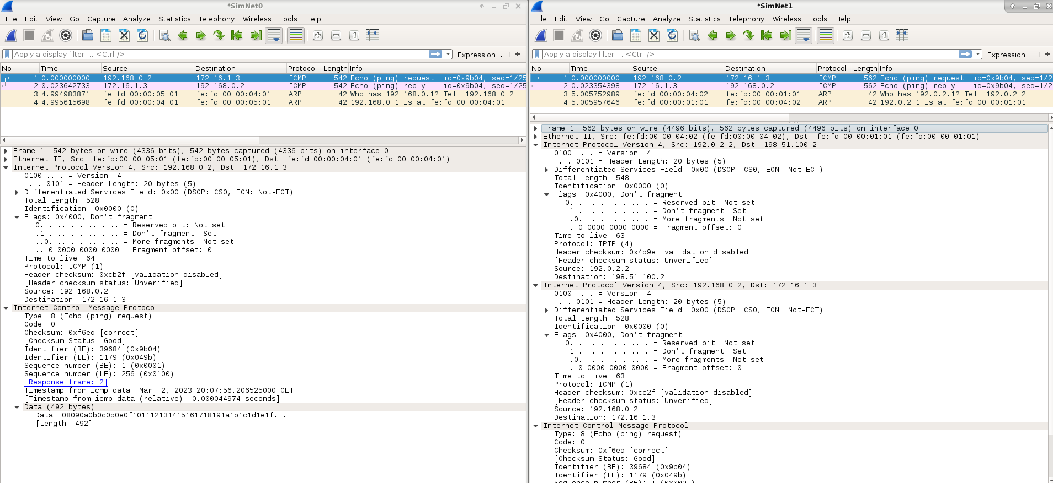
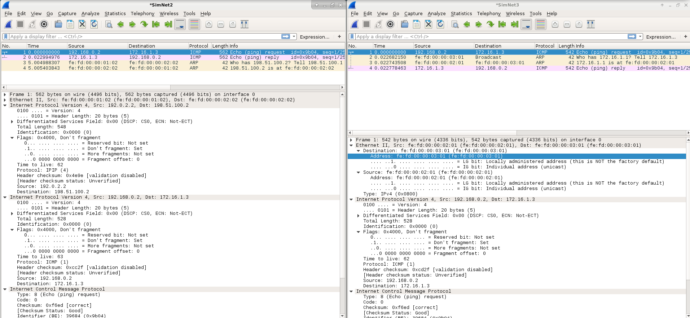
En todas las redes el DF esta ‘1’ lo que no permite la fragmentacion. En al red de encapsulamiento, Tanto inner como outer header tiene a ‘1’ el DF, pero solo el request.
Now that you understand how encapsulation is performed, calculate which is the size necessary to make the encapsulated packet have the maximum sized alowed by SimNet2. Send a ping of this size and verify that there is no fragmentation.
The minimum size to not fragment is 976B of ip packet: including data, icmp and inner header. Due to once the outer header is added the size of the packet will be 996B.
To be able to sent a packet doing in command we have specified the value -s 948, because we have to sum the 8B of icmp header + 20 ip header = 976.
The command that works is:
ping -c1 -s 948 -M do @ip_host
-s specifies the Bytes of the data.
The -M want option
Host: simctl iptunnel exec flushcache
- Delete the kernel routing cache executing the label flushcache.
- Put all wiresharks listening traffic in all SimNet interfaces.
- Execute the following command in host2:
h o s t 2 $ ping 􀀀c1 􀀀s 1000 􀀀M want 1 7 2 . 1 6 . 1 . 3
- Is the ping working?
No, the ping is not working.
- How many ICMP packets can you see in SimNet0? What kind of packets? Is set the DF flag in the IP header of the ICMP echo-request?
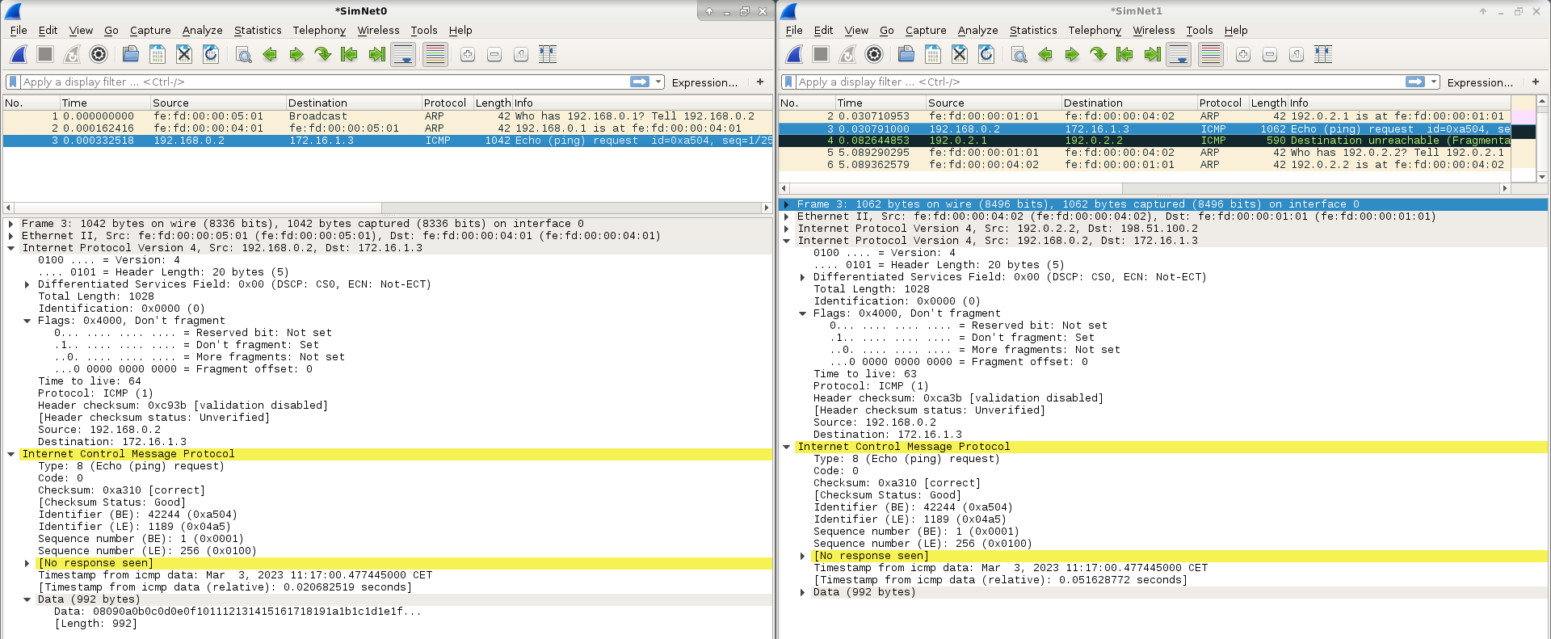
No hi ha paquets a SN2 i SN3.
- And in SimNet1, what packets can you see? Is the DF flag set in the IP headers (inner and outer)? As you can see, there is an error produced by the MTU by means of a message ICMP fragmentationneeded. This error apears due to the DF flaf is Set in the Outer IP header of the ICMP echo-request message.
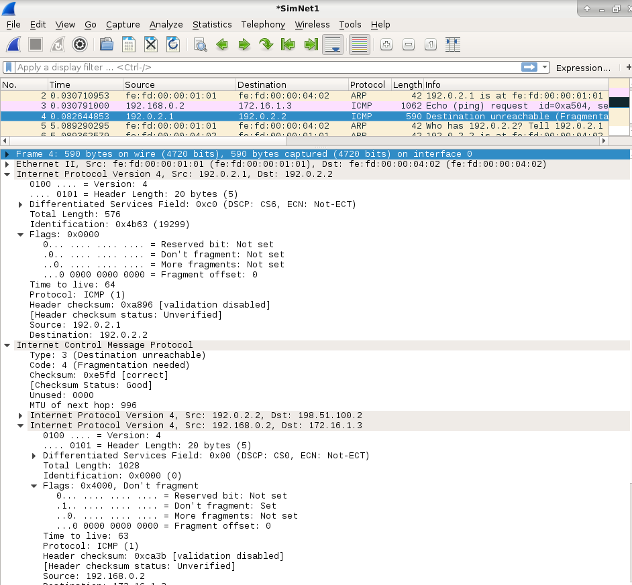
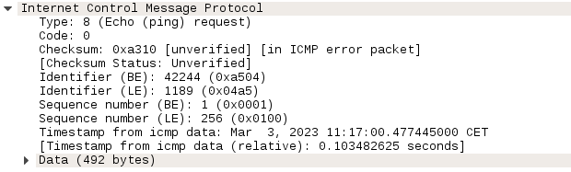
- What device is the origin of the ICMP fragmentation-needed message? And the destination? Which is the maximum MTU notified in this message?
- In your opinion, what entity should be the proper destination of this message?
- According to RFC2003 (see Section 4.1), is R1 acting as relay of the message and sending it to host3?
As you can see, in the case of fragmentation-needed messages, the encapsulator is not performing ICMP Relaying. Instead, the encapsulator uses soft state to inform the origin host about the error. To show this, we are going to send more than one message to use the kernel routing cache:
- Delete the kernel routing cache executing the label flushcache.
- Put all wiresharks listening traffic in all SimNet interfaces.
- Execute the following command in host2:
h o s t 2 $ ping 􀀀c2 􀀀s 1000 􀀀M want 􀀀i 1 1 7 2 . 1 6 . 1 . 3
With this command we are sending two ICMP echo-request messages with 1000 Bytes of data and separated by an interval (-i option) of 1 second.
  - Is the ping working? How many ICMP messages can you see in SimNet0? Is the DF flag set in the IP header of these messages?
No
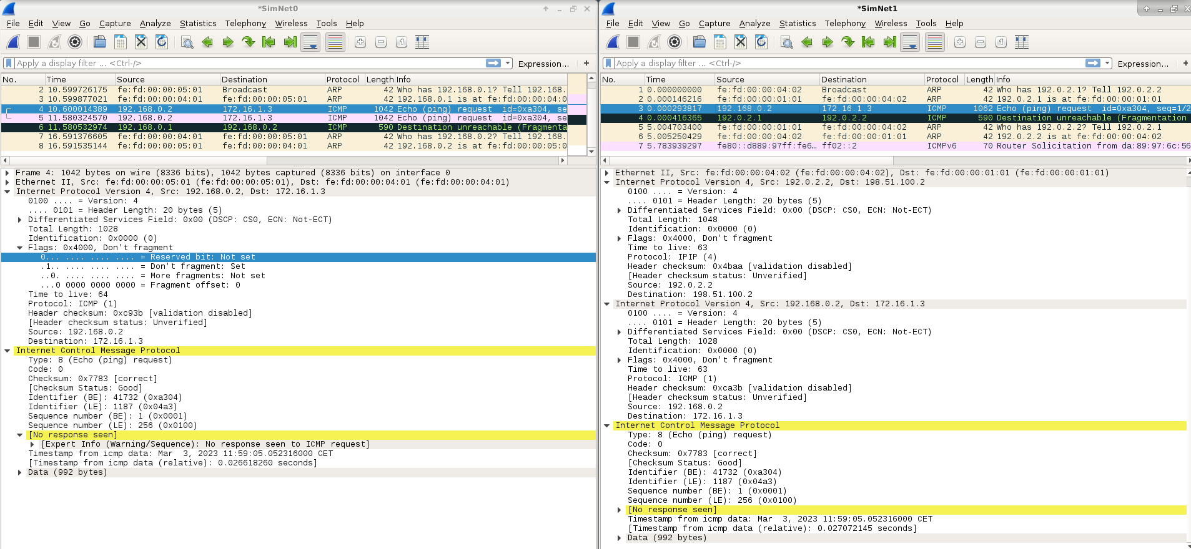
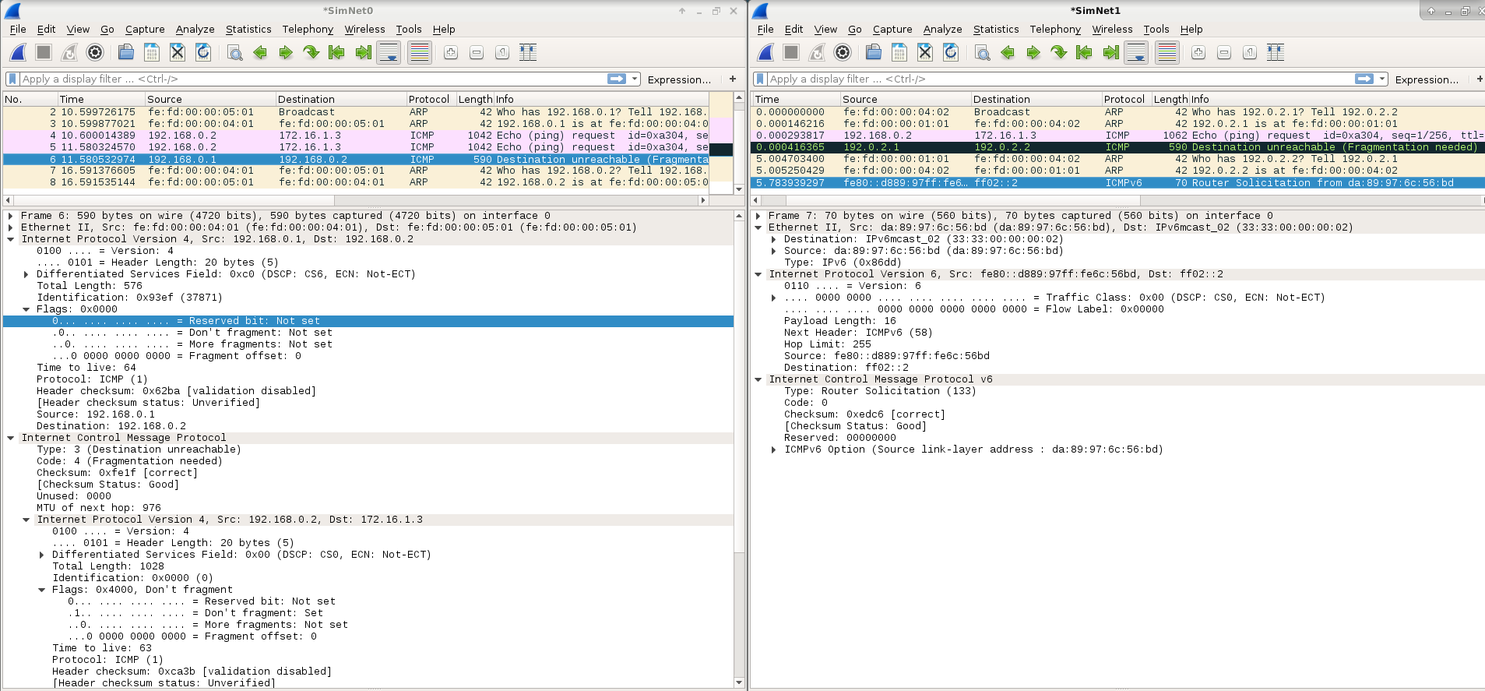
  - In SimNet1, how many ICMP echo-requests can you see? What about the DF flag?
  - Can you see an ICMP fragmentation-needed message in SimNet0? Which is the origin and destination of this message? Which is the maximum MTU notified in this message?

  - Do you think that R1 maintains a soft state of the MTU of the tunel?
This soft state can be seen by executing the following command in R1:
R1$ i p r o u t e show c a che
. . .
1 7 2 . 1 6 . 1 . 3 dev t u n n e l 0 s r c 1 9 2 . 0 . 2 . 2
c a che e x p i r e s 596 s e c i p i d 0 xf9ba mtu 976
. . .
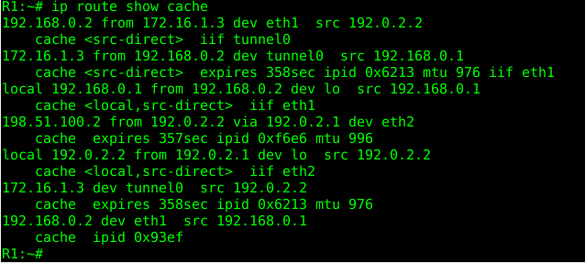
Notice that the information contained in this routing cache is ephemeral (10 min). If you lasted more than this time to execute the previous command maybe you will find the cache empty, so you have to repeat the experiment.
Now, we will send three ICMP echo-request messages:
- Delete the kernel routing cache executing the label flushcache.
- Put all wiresharks listening traffic in all SimNet interfaces.
- Execute the following command in host2:
h o s t 2 $ ping 􀀀c3 􀀀s 1000 􀀀M want 􀀀i 1 1 7 2 . 1 6 . 1 . 3
Now let us analyze this test in detail:
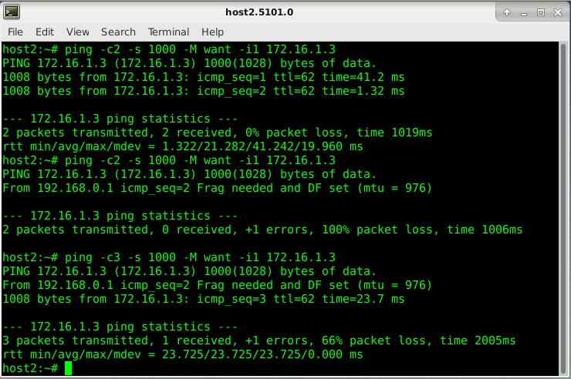
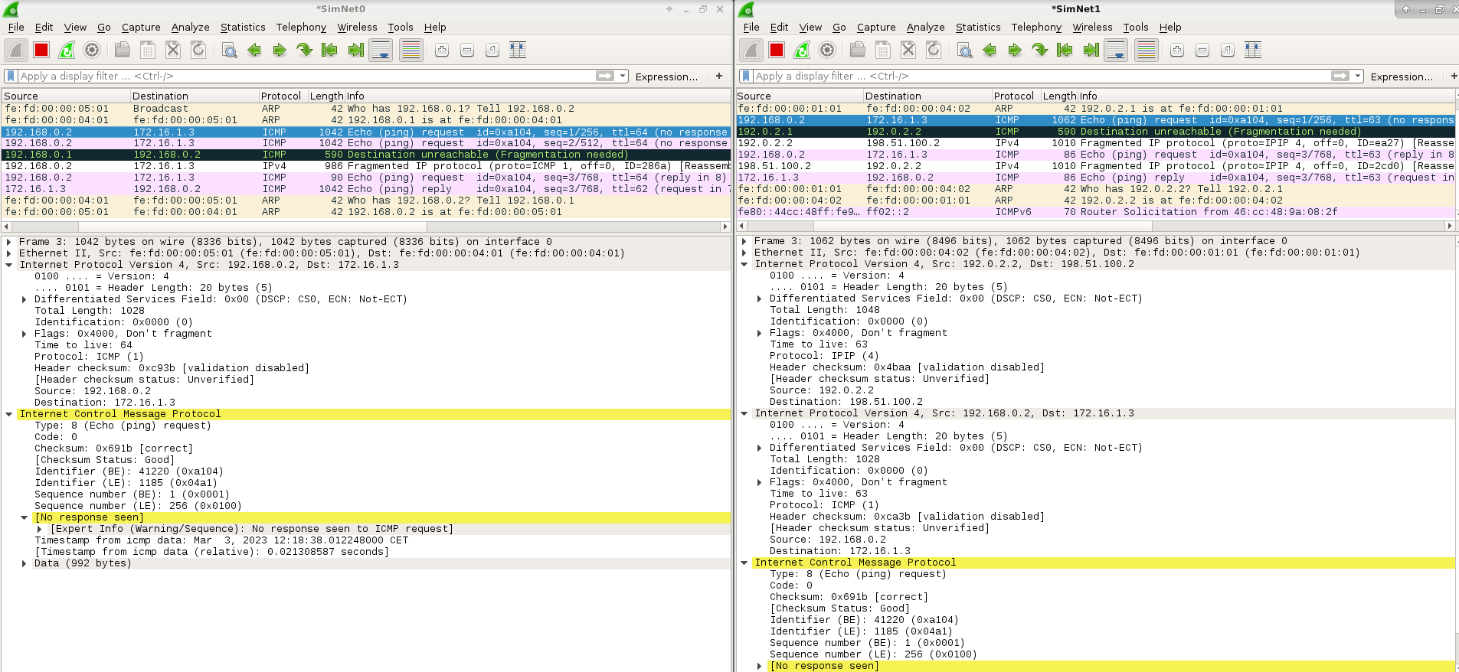
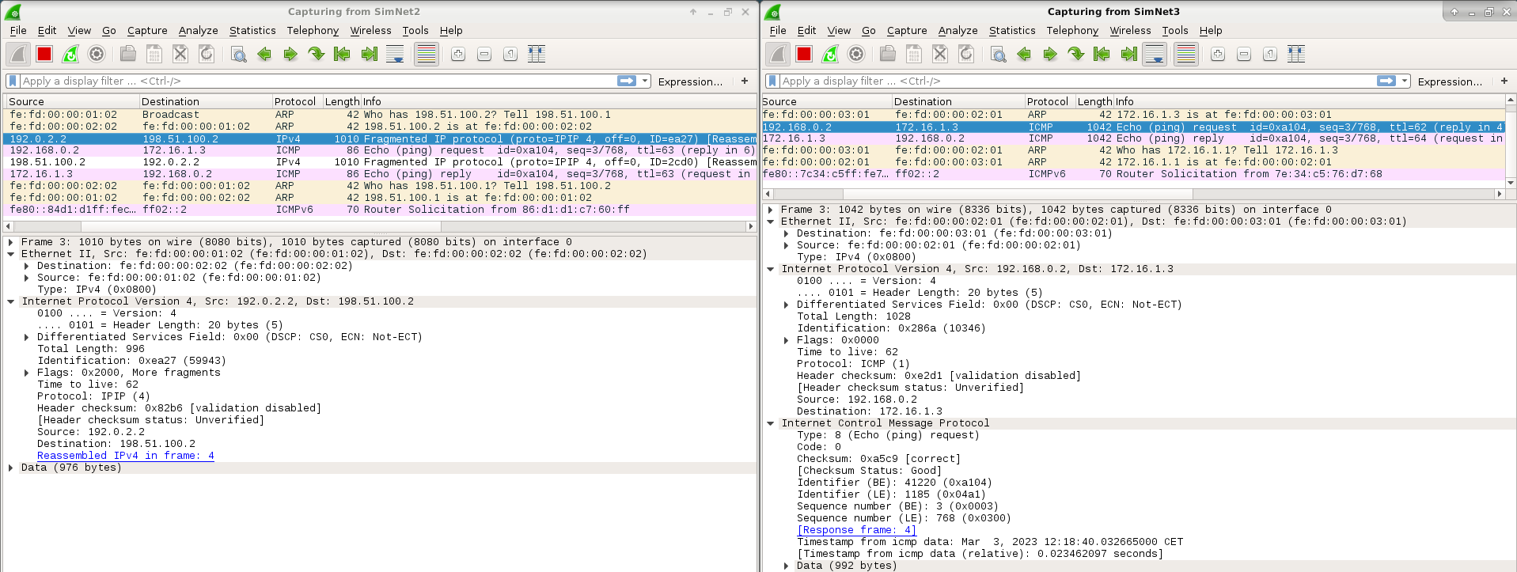
  - Is the ping working? How do you know that?
Yes, but only one of the three arrived at the destination.
  - In SimNet0, have a look at the DF flag in all the ICMP echo-request messages. What can you deduce? Is there any difference in the third ICMP Echo request message?
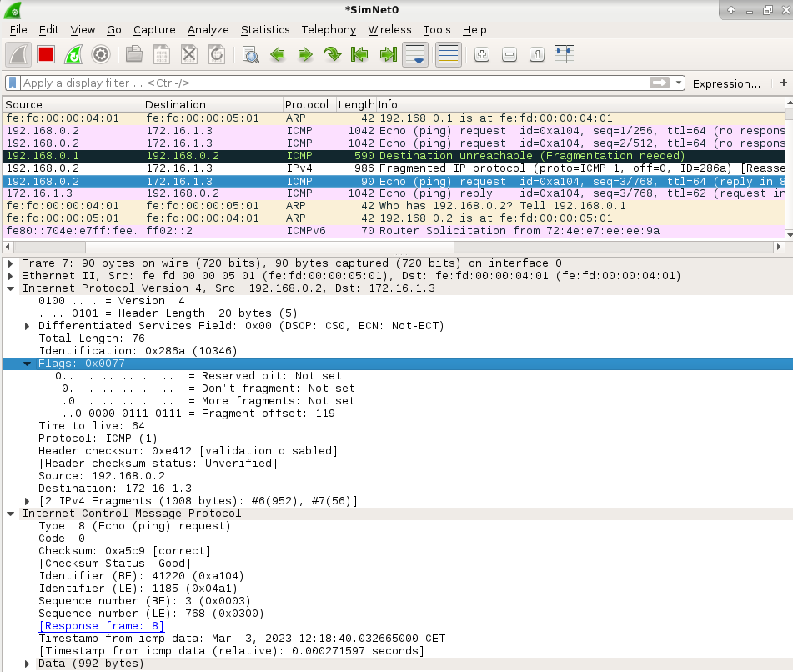
In the first 2 the DF flag is active and on the third after receiving the Fragmented IP protocol message the do not fragment is not set.
  - In SimNet0, who is performing the fragmentation of the third ICMP echo-request? Which are the sizes of the packets that compose this third ICMP echo-request? Take notes of the existing headers.
  - In SimNet1, how many fragmented packets can you see that correspond to this third ICMP echo-request? What about the DF flag in the Inner and Outer IP headers?

  - Describe in detail the sizes and headers of these packets. Is fragmentation performed in the same way than SimNet0? Why the difference? Notice that the Fragment Offset field in the IP header is meassured in units of 8 bytes.
  - In SimNet3, how many ICMP echo-requests can you see? Describe sizes and headers.
We can only see one ICMP echo-request.
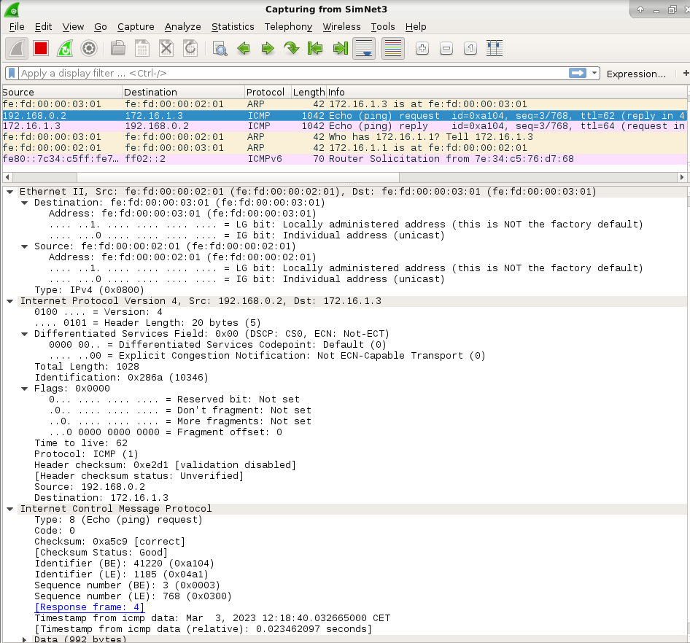
  - In SimNet3, how many ICMP echo-reply messages can you see? Describe sizes and headers.
We can only see one echo-reply:
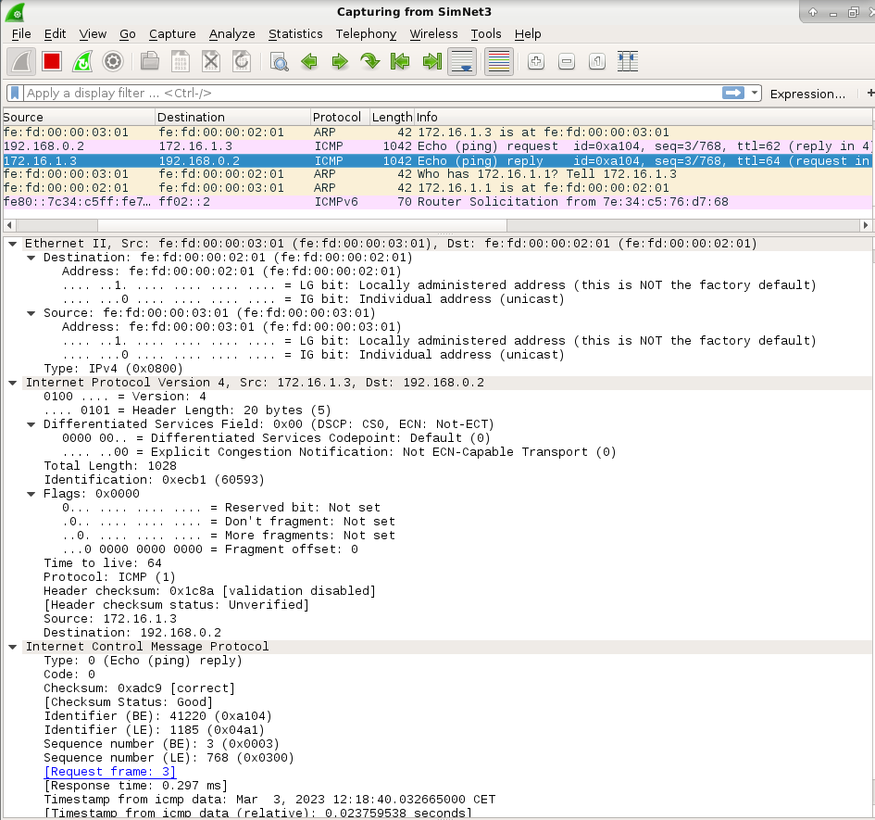
  - In SimNet2, how many fragmented packets can can you see that correspond to this third ICMP echo-reply? Describe in detail sizes of these packets and headers. Is fragmentation performed in the same way than for the ICMP Request message? Describe in detail sizes of these packets and headers.
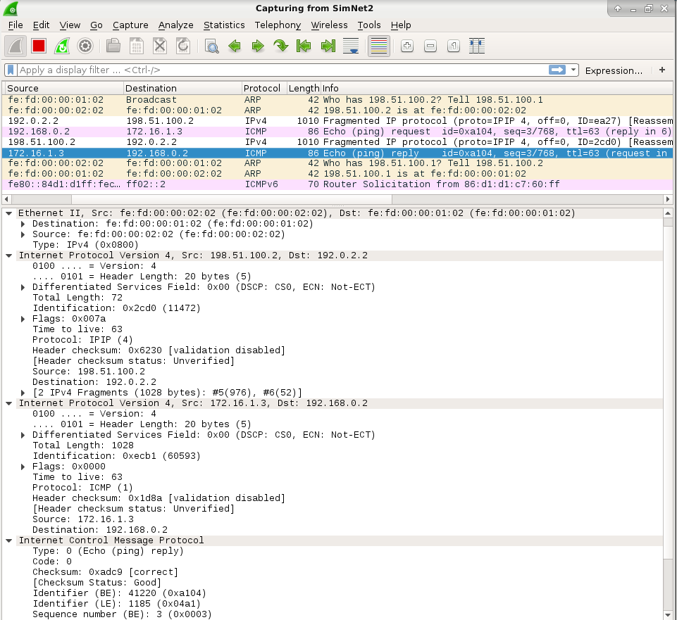
Finally, we will send the latest ping of this series:
- Delete the kernel routing cache executing the label flushcache.
- Put all wiresharks listening traffic in all SimNet interfaces.
- Execute the following command in host2:
h o s t 2 $ ping 􀀀c2 􀀀s 1460 􀀀M want 􀀀i 1 1 7 2 . 1 6 . 1 . 3
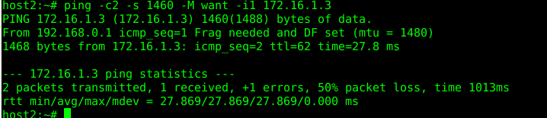
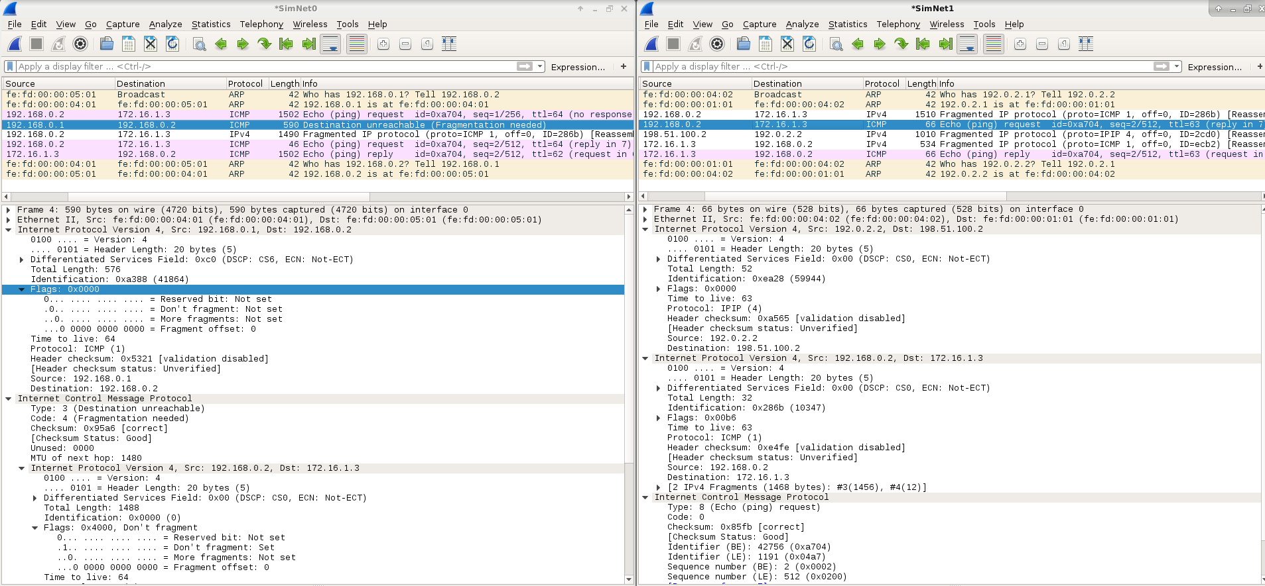
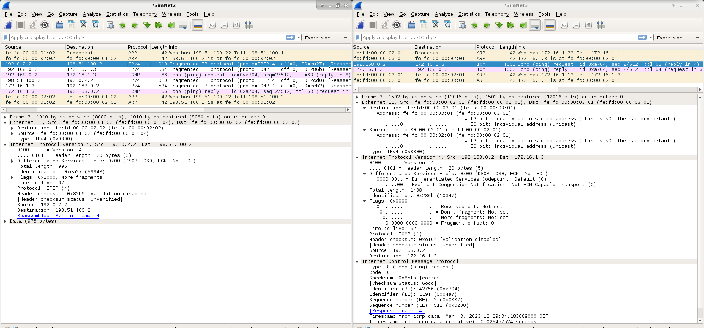
  - Is there any error message? Who is the sender of this error?
  - Which is the value of MTU that is reporting this error message? Is this value the real path MTU value? Why there are no more errors during the transmission? Have a look to the DF flag.
Falta the-M do option
Falta -M don’t option

0.7 Testing tunnels: pmtudisc
All previous test were performed using the nopmtudisc option when creating the tunnel. Let us change this option to
see if there is any difference.
1. Delete the previously configured tunnel:
HOST$ s imc t l i p t u n n e l exe c d e l t u n
2. Reestablish again the tunnel but now with the pmtudisc option enabled:
HOST$ s imc t l i p t u n n e l exe c addtun_pmtu
Now, verify the configuration in both edge routers with this command:
$ i p t u n n e l show
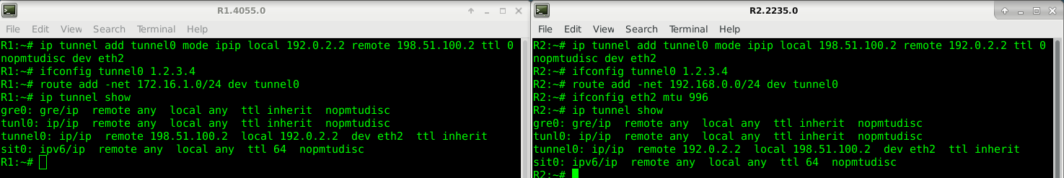
Also, verify that the MTU in both sides of the tunnel is the proper one.
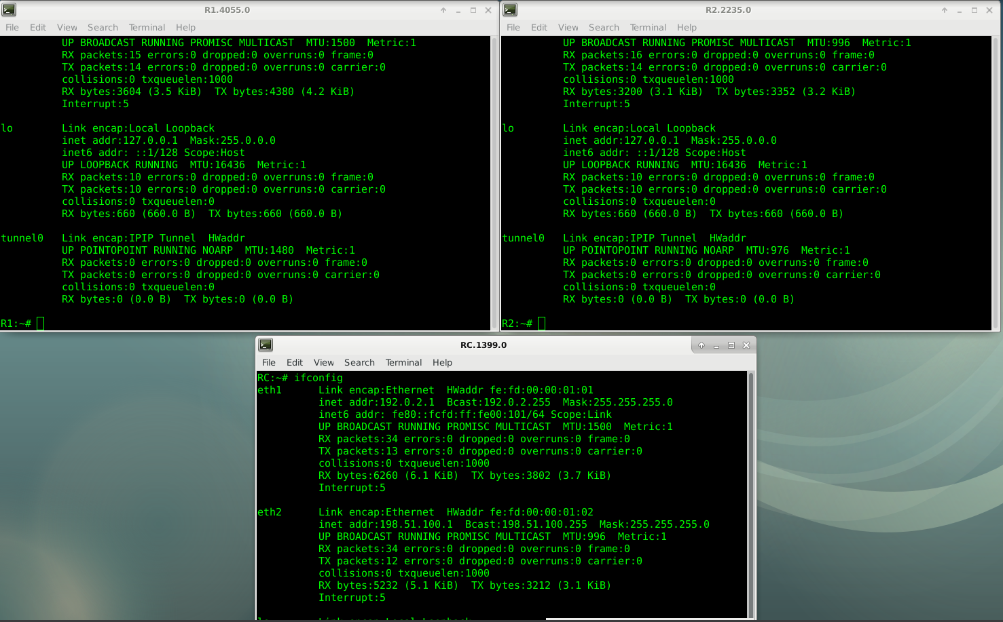
Now, do the following test:
1. Delete the kernel routing cache executing the label flushcache.
2. Put all wiresharks listening traffic in all SimNet interfaces.
3. Execute the following command in host2:
h o s t 2 $ ping 􀀀c3 􀀀s 1000 􀀀M want 􀀀i 1 1 7 2 . 1 6 . 1 . 3
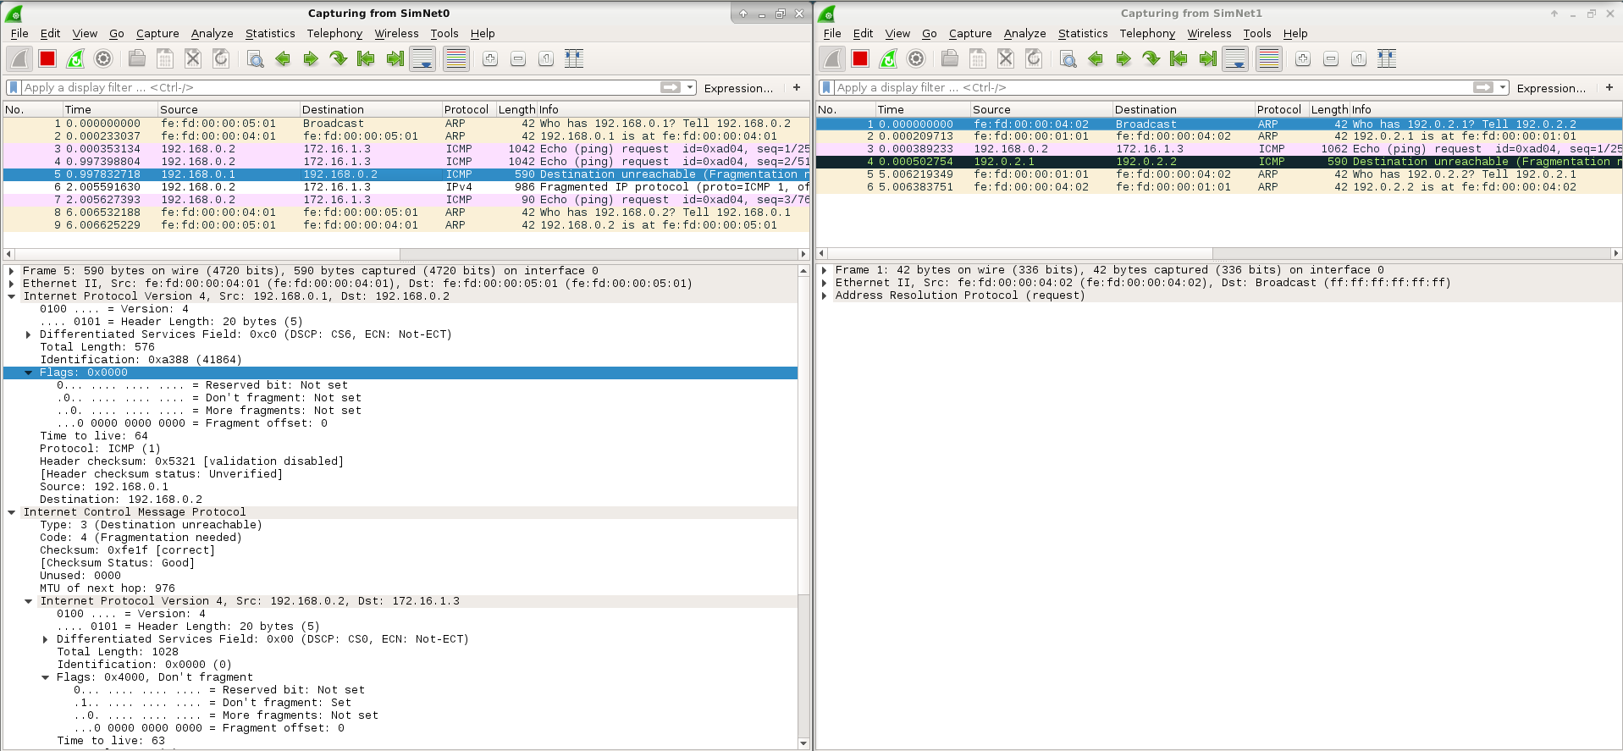
(a) Is the ping working? How many ICMP echo-request can you see in SimNet0? Is there any error
message? In which network?
No, it is not working. There are 3 ICMP echo-request in SN0, and an error message indicating that the destination is unreachable, because fragmentation is needed.
(b) Try to explain the behavior of the encapsulator.
Now, let us test with the -M do option:
1. Delete the kernel routing cache executing the label flushcache.
2. Put all wiresharks listening traffic in all SimNet interfaces.
3. Execute the following command in host2:
h o s t 2 $ ping 􀀀c3 􀀀s 1000 􀀀M do 􀀀i 1 1 7 2 . 1 6 . 1 . 3
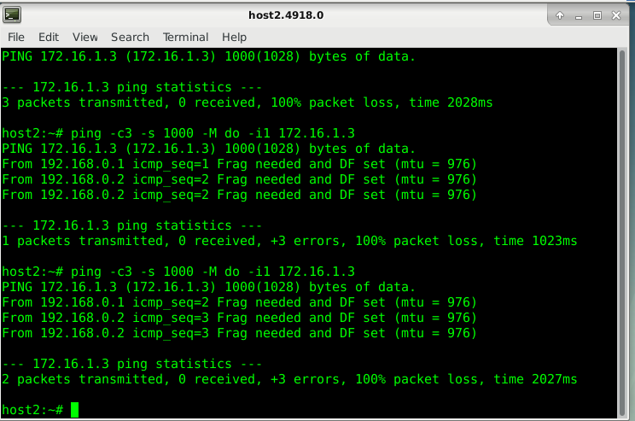
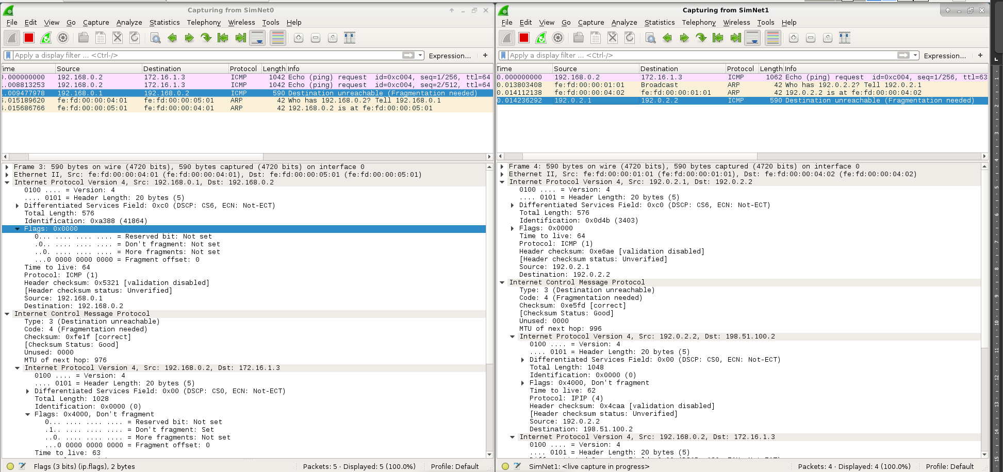

- What is the difference regarding the previous test?

Finally, let us test the latest -M dont option:
1. Delete the kernel routing cache executing the label flushcache.
2. Put all wiresharks listening traffic in all SimNet interfaces.
3. Execute the following command in host2:
h o s t 2 $ ping 􀀀c3 􀀀s 1000 􀀀M dont 􀀀i 1 1 7 2 . 1 6 . 1 . 3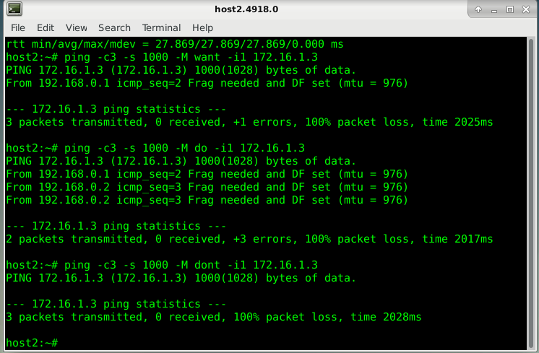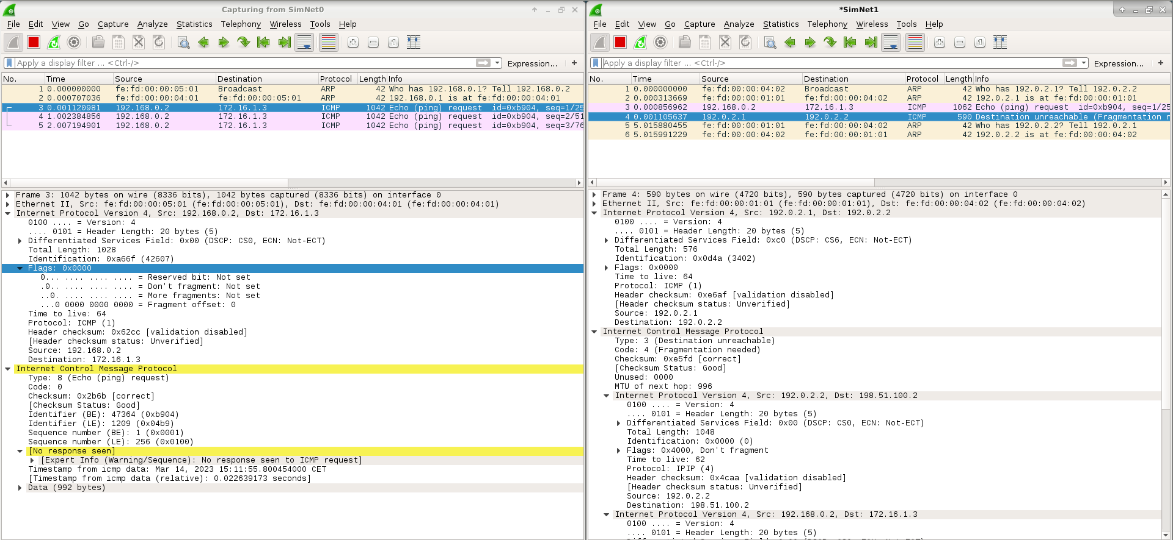
- Is the ping working? How many ICMP echo-request can you see in SimNet0? Is the DF Set in thepackets in SimNet0?
- In Simnet1, can you see ICMP echo-request packets? Which one, the first, second or third?
- Is there any error message in SimNet1? Why this error? Have a look to the DF flag in inner and outerheader echo-request.
- Why the encapsulator is not sending the rest of pings towards the tunnel? Consult the kernel routing cache.

0.8 Testing tunnels: TCP and MSS
Now you are going to test how the TCP protocol behaves when the connection go through a tunnel. First, reestablish the tunnel with the option nomptudisc. Leave the MTU=996 in SimNet2.
HOST$ simctl iptunnel exec deltun
HOST$ simctl iptunnel exec addtun_nopmtu

0.8.1. Netcat and TCP
Fisrt we will start doing a correct transmission (without filtering rules) using netcat:
1. Put all wiresharks listening traffic in all SimNet interfaces.
2. Start a netcat server in host3 listening in port 12345 (the -l option means listen, that is, this host is behaving as server): host3$ nc -l -p 12345
3. Start the netcat client in host2: host2$ nc 172.16.1.3 12345
Netcat is used to establish a TCP connection between host2 and host3. As you can see, the tool behaves like a chat, and if you type something on the keyboard of one host, it appears in the other side. If you want to close netcat, you can type Ctrl+C, and the TCP connection will be closed. Have a look to all wiresharks and answer:
(a) Can you see the classical 3-way handshake of TCP?
(b) Which is the value of the MSS (Maximum Segment Size) advertised in this handshake?
(c) What is the meaning of this MSS? Can have the client a MSS different from the server?

0.8.2 Netcat to transfer files
Netcat can also be used to transfer files:
- Delete the kernel routing cache executing the label flushcache.
- Put all wiresharks listening traffic in all SimNet interfaces.
- Start the netcat server in host3, that will send the file /etc/services towards the client when the connection has been established: host3$ nc -l -p 12345 -q 0 </etc/services
- Start the netcat client in host2, that will display in the screen the file /etc/services of the server: host2$ nc 172.16.1.3 12345
  - In the 3-way handshake, which was the value of the MSS?
  - Did you notice any problem during the transmission according to the wiresharks?
  - Can you see any ICMP message in SimNet3? Who is sending these error messages and why?
  - Was the file transmitted properly? Who solved the problem?
  - Is this meaning that the MSS has changed during the transmission?
As you can see from the previous example, TCP is a reliable protocol. This means that it will retransmit lost information until it is properly received (or after a certain number of unsuccessful retransmissions). TCP is able to change the lenght of the segments in case that the network reports problems of size, but this does not mean that the MSS changes, as it is a fixed value. Obviously, files can be transmitted in both directions using netcat. In the previous example, we made a transmission in which the server transferred a file towards the client. Now we will test this same operation in the reverse direction.
- Delete the kernel routing cache executing the label flushcache.
- Put all wiresharks listening traffic in all SimNet interfaces.
- Start the netcat server in host3:
- Start the netcat client in host2, but in this case inject the file /etc/services of the client towards the server using the TCP connection.
  - Which are the commands that you used to do the previous behavior?
  - Did you notice any problem during the transmission according to the wiresharks?
  - Can you see any ICMP message in SimNet0 and SimNet1? Who is sending these error messages and why?
  - Was the file transmitted properly? Who solved the problem?
  - According to the transmission, who is the TCP client and who is the TCP server?
Again, TCP solved the problem by adapting the lenght of the segments to the network conditions and retransmitting lost information. Notice that the TCP client is the host that started the TCP dialogue by sending the first message SYN, and the TCP server is the host that answered by sending the SYN-ACK message, no matter of the direction of the data transmission.

0.8.3. TCP, tunnels and filtering
A problem that appears in actual networks is that some networks administrators filter all traffic that they suppose to be dangerous. In this case, it is usual to filter almost all UDP traffic (except the DNS) and in general all ICMP traffic. Now we are going to test what happens when error messages are not able to reach the destination host. In particular, we will see which are the consequences of filtering Fragmentation Needed messages.
- Let us imagine that the network administrator of R1 wants to protect this router against typical attacks that use ICMP. For this reason, it avoids sending ICMP messages to this router. So, execute the following command to filter the ICMP traffic whose destination is R1: R1$ iptables -A INPUT -p icmp -j DROPç
- Delete the kernel routing cache executing the label flushcache.
- Put all wiresharks listening traffic in all SimNet interfaces.
- Again using netcat, send the file /etc/services from host2 (acting as client) towards host3 (acting as server).
  - Can you see the 3-way handshake? Did you notice problems with these 3 initial messages?
  - Did you notice problems with data segments? Why? Which is the difference with the previous ones?
  - Can you see any ICMP message in SimNet1? And in SimNet0?
  - Was the file transmitted properly? Why?
  - What will happen if instead of the INPUT chain, we use the FORWARD chain in the filtering rule?
As you can see, the client is not receiving feedback from the errors of the network due to the filtering rule, so it is unable to addapt the TCP transmission to the conditions of the network. TCP assumes that losses are due to congestion, so it will try to retransmit lost segments just waiting more and more time.

0.8.4 Changing the MSS
Obviously, the previous problem can be solved by deleting the iptables filter rule in R1, but this may be impossible if we do not have the admin rights to do so. As an alternative solution, it is possible to change the advertised MSS to a different value, so tunneled packets do not need to be fragmented in path. So, we have to change the advertised MSS in the 3-way handshake to a different value from the one calculated by default in the host (and which mainly depends on the MTU of the exit network interface).
There are some issues that should be considered prior to doing this change:
- Which is the value of the MSS that avoids fragmentation in path? To calculate this, we should clearly know and understand the notion of MTU, MSS and encapsulation. Remember that the MSS counts only DATA octets in the segment, and it does not count the TCP header or the IP header. So, the MSS is calculated as the most restrictive MTU in the path minus the minimum IP, TCP and tunnel headers.
- Which message in the 3-way handshake (SYN or SYN/ACK) should be modified. Remember that the client informs to the server about its MSS using the SYN segment (so this affects data that go from the server to the client), meanwhile the server informs to the client about its MSS using the SYN/ACK segment (data from the client to the server).
- Where we can change this MSS, hosts or routers?
  - Changing the MSS in the end systems (origin or destination). In Linux systems it is possible to force that the TCP connections that use a certain route use a particular MSS during the establishment phase. In general, the command is ip route add ROUTE advmss VALUE where ROUTE is the route we want to add (more information using ip route show), and VALUE is the “Advertised MSS” in bytes. In case the route exists, instead of add use change. Just as an example (not related with this particular case of the lab session), let us imagine that we want to change the MSS that host2 advertises in the 3-way handshake to the value 1440. In this particular case, the command would be: host2$ ip route add 172.16.1.0/24 via 192.168.0.1 advmss 1440
  - Changing the MSS in the routers. If the TCP traffic goes through a router that we manage, it is possible to modify the advertised MSS in the 3-way handshake. To do so, we will use iptables, and in particular the “mangle” table. This table is used to modify packets, and it may be used with the chains PREROUTING, INPUT, FORWARD, OUTPUT and POSTROUTING. The chain associated to the change of MSS is TCPMSS, and it has two parameters:
    - --set-mss value: to establish the MSS to value in bytes.
    - --clamp-mss-to-pmtu: to establish the MSS to the one obtained via PMTUD.
For instance:
    - iptables -t mangle -A FORWARD -o tunnel0 -p tcp --syn -j TCPMSS --set-mss 1440
With this command, the linux router will change the MSS to 1440 bytes to those TCP packets with the SYN flag set (and the rest of flags not set) and that exit the router via the interface tunnel0.

Change the MSS in the host
So, we are going to try to solve the previous transmission but changing the MSS in the hosts.
- Delete the kernel routing cache executing the label flushcache.
- Put all wiresharks listening traffic in all SimNet interfaces.
- Identify which are the proper parameters to change the mss properly:
  - Which is the value of the advertised MSS to avoid fragmentation in path? Notice that the MTU in Sim-Net2=996.
  - Which message of the 3-way handshake of TCP should be change? Why?
  - If we are changing the MSS in a host, which is the host where we should execute the command?
- Now that you fully know all the parameters to properly change the MSS, use ip route to change it.
- Using netcat again, send the file /etc/services from host2 (acting as client) towards host3 (acting as server).
  - Did you notice problems with data segments?
  - Can you see any ICMP message in SimNet1 and SimNet0?
  - Was the file transmitted properly?
Prior to continue with the following test, delete the route that you configured in the host to change the MSS.

Change the MSS in the router
Now we are going to simulate a quite typical problem that appear when doing web browsing and tunnels. There is a web server (apache2) listening in host2. Notice that when using simctl, we cannot use web browsers that require the graphical interface (like firefox or chrome). Instead, we are going to use lynx, a text-based web browser. To see the web page, you can go to host2 and execute the command: host2$ lynx localhost
As you can see, the web page is very simple, it only contains some few sentences and a link towards another local web page. You can browse that other web page by using the arrow keys. Obviously, we do not pretend to connect to the web server locally, but remotelly from host3. So, let us start the experiment:
- Delete the kernel routing cache executing the label flushcache.
- Put all wiresharks listening traffic in all SimNet interfaces.
- Connect to the web server of host2 using lynx from host3: host3$ lynx 192.168.0.2
  - Can you see the main web page of host2?
  - Can you see any error message in the wiresharks?
- As you can see there is no problem to see the main web page of this host. However, browse the web in order to see the other local web page:
  - Did you noticed any error?
  - What do you see in the wiresharks?
  - Why do you think that the main web page is working, but the second one cannot be downloaded?
  - Try to solve the problem by changing the MSS in R2 using the MANGLE table of iptables. Remember that you have to change the MSS in the proper message of the 3-way handshake.
We hope that all these experiments helped you to understand how complicated is to solve problems of communication networks when using tunnels, even in the case of using the most simplistic IPIP tunnel. In following lab sessions, maybe you will be asked to create GRE tunnels, so try to remember all these concepts.

